# DECA PROJECT REPORT

# Agam Aggarwal(20CSU203)

# OBJECTIVE: Fire Alarm System Project

**Hardware/Software:** Software **Tinkercad**

https://www.tinkercad.com/things/9mi0FPMmd1J-terrific-trug-jofo/editel?sharecode=kdE9owGz88F1ggGrn5Ysn6g06c6mVoUtwUXXxQUYyMY

**Theory:**

Fire Alarm System is designed to alert us to an emergency so that we can take action to protect ourselves, staff and the general public.

Fire alarms are found in Offices, Factories, and public buildings, they are a part of our everyday routine but are often overlooked until there is an emergency at which point, they might just save our lives.

## **Hardware Requirements**.

To build a low cost Fire Alarm the requirements are -

**1. Arduino UNO Board.**

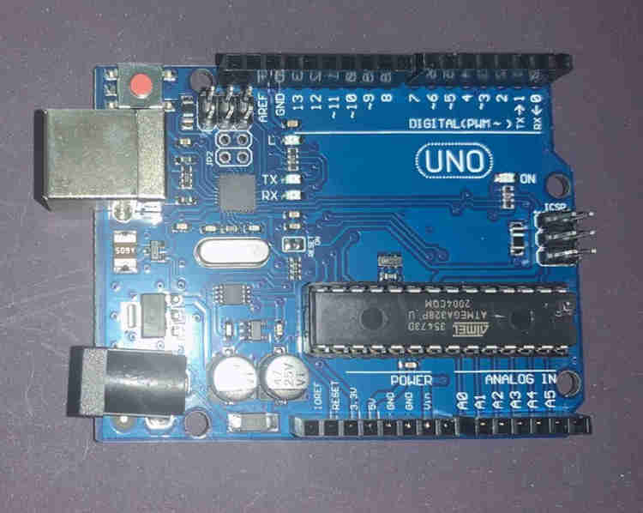

Arduino UNO

[#Arduino](https://www.learnelectronicsindia.com/blogs-1/search/.hash.arduino) board is a microcontroller that is used to accept inputs from sensors connected and provide an output action on the desired device connected to it. The sensor inputs can be from light-detecting sensors, motion sensors (Ultrasonic or IR), temperature sensors, etc. The output from this device can be received through other output devices such as LED, Buzzer, Serial monitor, etc.

2. **LM-35 Temperature Sensor**

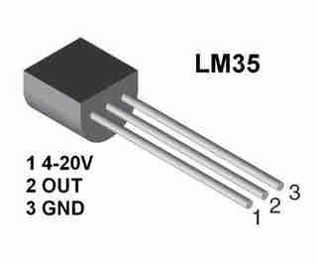

LM-35 Flame Sensor

LM-35 [#Temperature](https://www.learnelectronicsindia.com/blogs-1/hashtags/Temperature) Sensor gives an analog output based on the instantaneous temperature value. This analog output is proportional to the instantaneous input.

3. **Gas sensor**

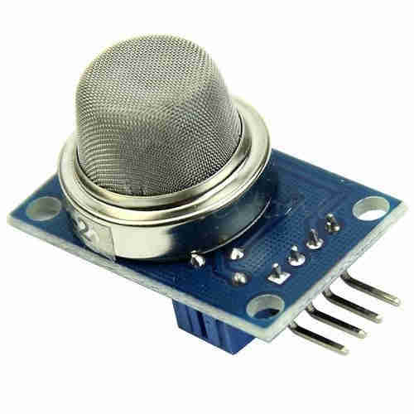

MQ2 Gas sensor

The **gas** [**sensor**](https://www.learnelectronicsindia.com/blogs-1/hashtags/sensor) is used to measure the concentration or presence of gas in the atmosphere. It is also used to detect smoke in the air. Based on the gas, a potential difference is generated by changing the resistance of the material present inside the sensor. The output is measure in terms of Voltage.

.

4. **Resistors**

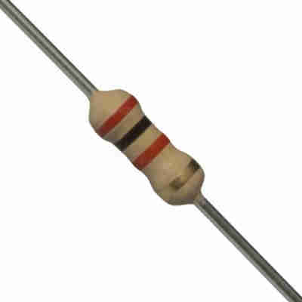

1k Ohm Resistor

Resistors are passive devices that restrict the flow of current or divide the voltage through the circuit. The input power passes through these resistors and then to the sensors to avoid damage.

5. **Breadboard**

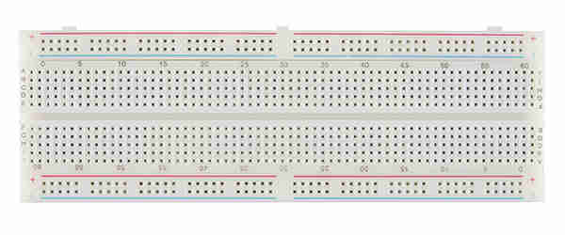

Breadboard

The breadboard is the basic component of any circuit building process. All components, be it input sensors or output display devices are connected to the power supply, microcontroller using wired connections through a breadboard. The holes in the breadboard are in series. There are various sizes like full-sized, half-sized, and mini breadboard.

**LED**

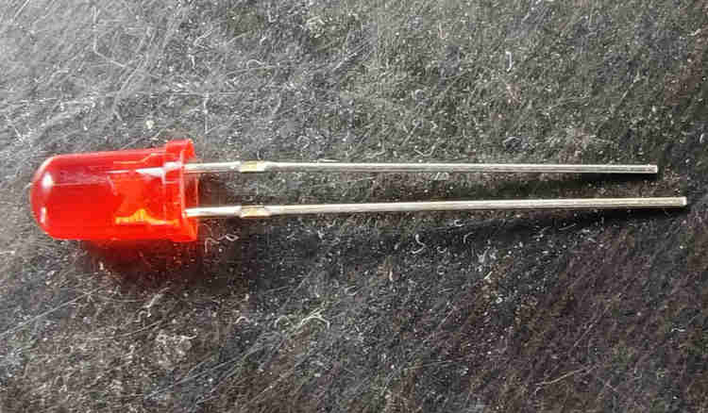

Light Emitting Diode is a commonly used light source. It is a semiconductor that emits light when current flows through it.

7. **Piezo Buzzer**

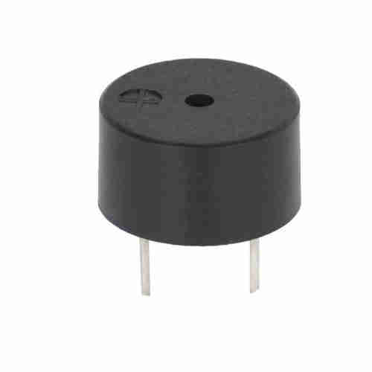

Piezo Buzzer

It is an electrical component that generates a beep sound on receiving an input. It works on the principle of [#piezo](https://www.learnelectronicsindia.com/blogs-1/hashtags/piezo) crystal.

8. **Jumper Wires**

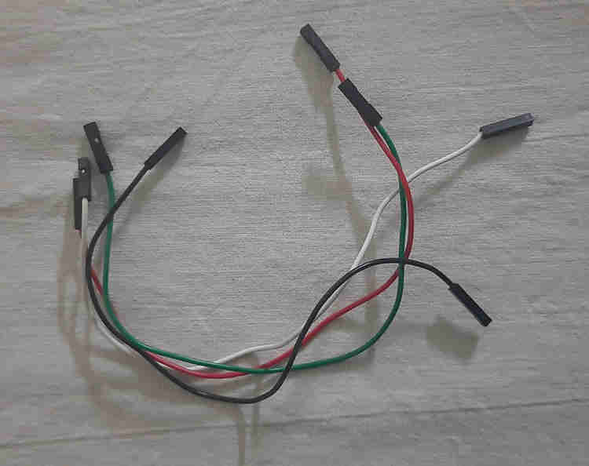  
These are the main components that are used to establish the connections between different devices of the circuit.

**Working of the circuit, we can understand it in two parts.**

**Part 1: Temperature sensor and its output.**

The Temperature sensor takes in input and when the temperature increases, the voltage increases, and hence the output initiates the functioning of the Buzzer. For every one degree increase in temperature, there is a 10mV increase in the voltage.

**Part2: Gas sensor and its output.**

A gas sensor is also used to detect smoke along with the concentration of gases. Based on the type of gas present in the atmosphere, a potential difference is developed by changing the Resistance of the material present inside the sensor and the same is measured as output.

The Concentration of the gas is measured in ppm and the output analog value is needed to be converted into digital which is done by the (Analog to Digital Converter) present in the sensor itself. Based on the condition given in the code, the LED glows or remains OFF.

**Code:**

float temp;

float vout;

float vout1;

int LED = 13;

int gasSensor;

int piezo = 7;

void setup()

{

pinMode(A0,INPUT);

pinMode(A1, INPUT);

pinMode(LED,OUTPUT);

pinMode(piezo,OUTPUT);

Serial.begin(9600);

}

void loop()

{

vout=analogRead(A1);

vout1=(vout/1023)*5000;

temp=(vout1-500)/10;

gasSensor=analogRead(A0);

if (temp>=80)

{

digitalWrite(LED,HIGH);

}

else

{

digitalWrite(LED,LOW);

}

if (gasSensor>=100)

{

digitalWrite(piezo,HIGH);

}

else

{

digitalWrite(piezo,LOW);

}

Serial.print("in DegreeC= ");

Serial.print(" ");

Serial.print(temp);

Serial.print("\t");

Serial.print("GasSensor= ");

Serial.print(" ");

Serial.print(gasSensor);

Serial.println();

delay(1000);

}

**Circuit diagrams:**

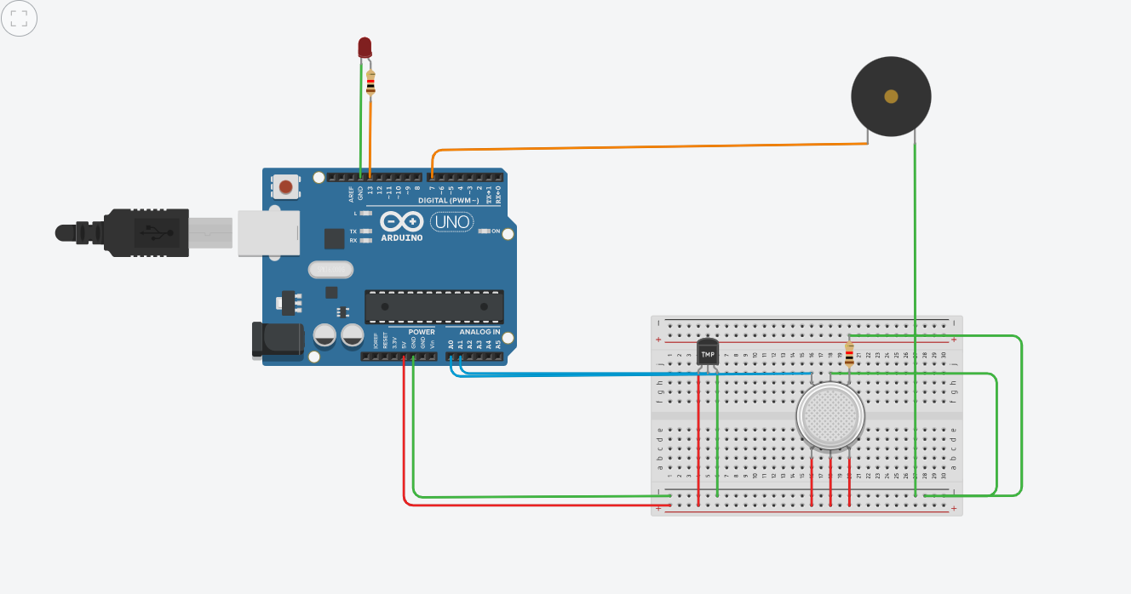

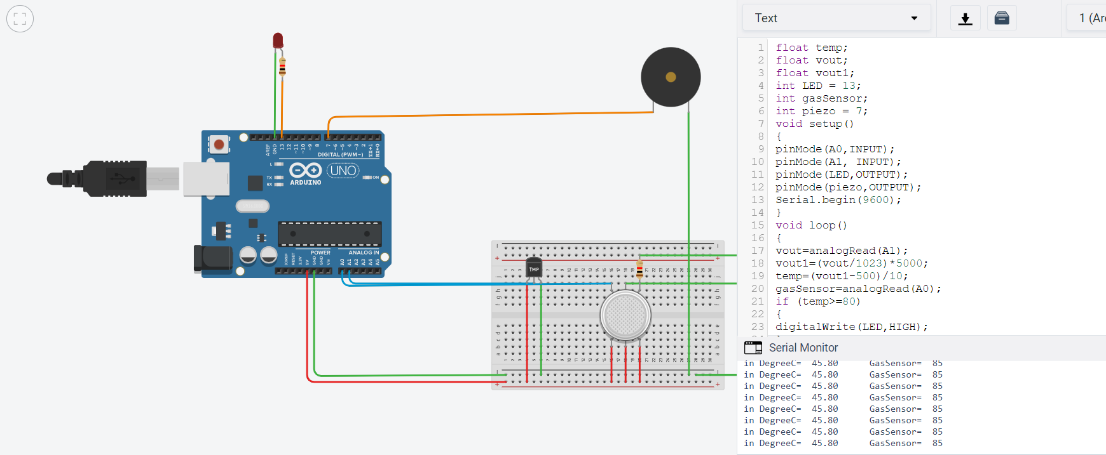

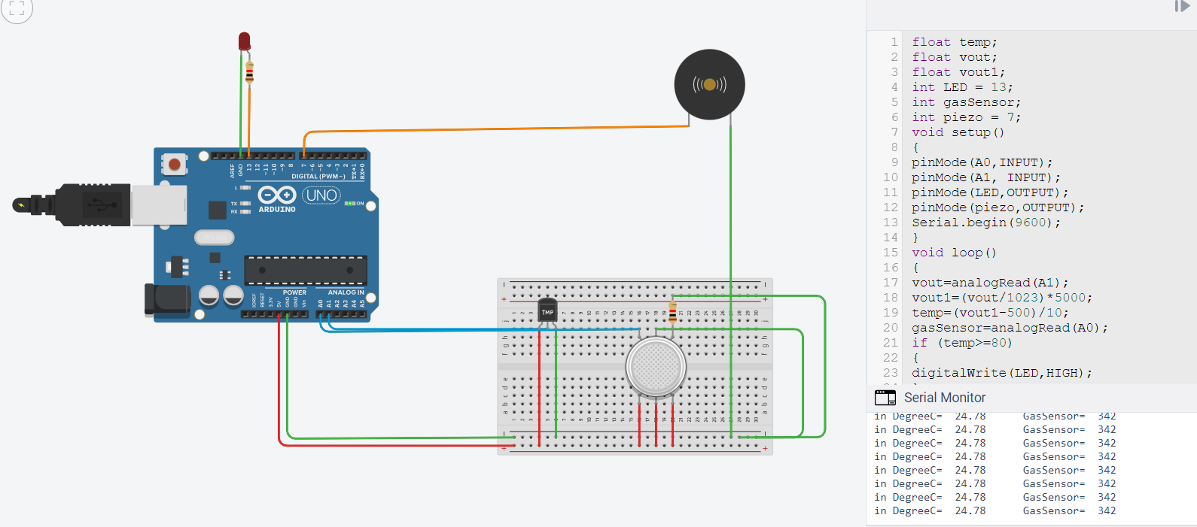

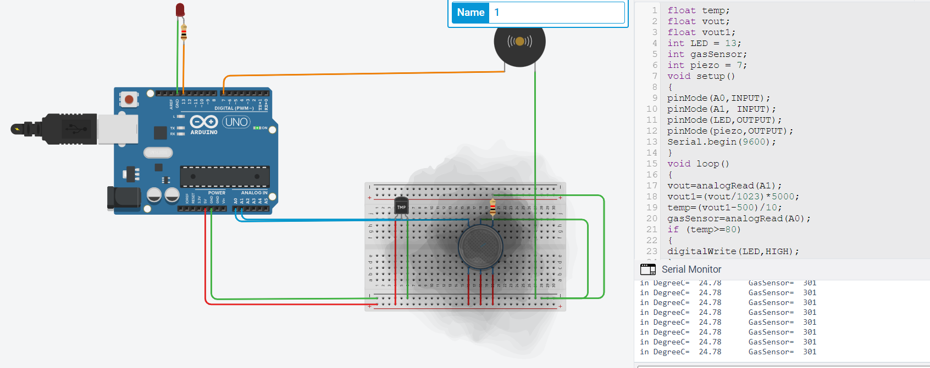

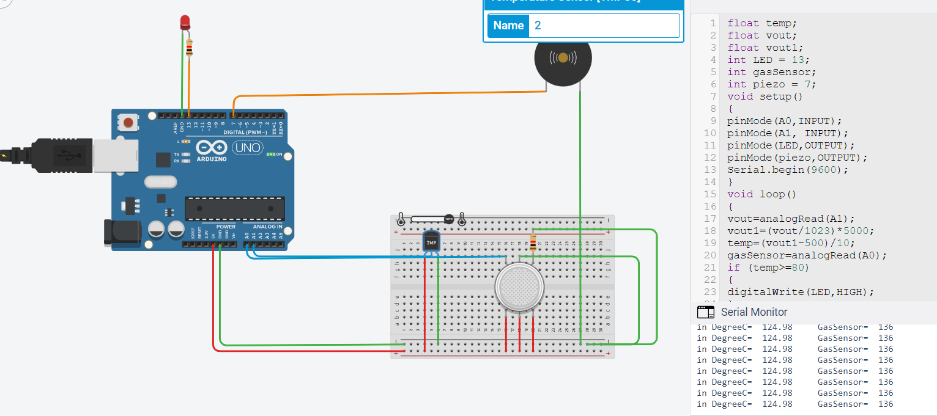

The earlier a fire is detected, the faster it will be that firefighters will respond. This can mean you may avoid major damage or even worse, the complete destruction of the home.

**Some Benefits of Fire alarm System are:**

### **Avoid Smoke Inhalation**

The most important reason is perhaps the only one you really need. This can save the life of anyone in the house at the time. This is particularly crucial at night time.

### **Early Detection**

The earlier a fire is detected, the faster it will be that firefighters will respond. This can mean you may avoid major damage or even worse, the complete destruction of the home.

### **Easy & Affordable**

Having a system is very reasonably priced

THANK YOU!!!!!!

**Agam20csu203**